Title / your Topic

Name  Study Program INF-B  Immatriculation no. 123456  account@st.ovgu.de | Name  Study Program INF-B  Immatriculation no. 123456  account@st.ovgu.de

Abstract
Abstract of your paper. Try not to exceed about 1500 characters (incl. spaces) or 250 words.
Keywords
You can enter some keywords here describing the research field(s) of your topic. For example:
Emotion Detection, Cryptography, Automotive IT

Darstellung des eigenen Szenarios und der Rollen
Text

DesigN der Lösung
Text

Realisierung
Text

Ergebnisse und deren Interpretation
Text

Subsections
To add subsections, use the respective format templates offered by Word.
This report was created in the context of the course “Mediensicherheit” summer term 2016.
This course was held by: Prof. Dr.-Ing. Jana Dittmann and Prof. Dr.-Ing. Claus Vielhauer; Research group Multimedia and Security, Otto-von-Guericke-University of Magdeburg, Germany.
The course was supported by: Dr.-Ing. Christian Krätzer

References
Try to reference all of your literature sources from the text and wherever applicable. This template uses a numbered style of references, e.g. [1], [2] etc. You can also do it in another format if you prefer. Other templates / conferences use combinations of author’s initials and year numbers, e.g. [MSB07] for a publication of Miller, Smith and Bernstein from 2007. Of course, the full literature information (complete author names, title of the paper or book etc.) will have to be provided in the literature list, see below.

Tables
Table titles should be placed above.
Table 1. Table captions should be placed above the table
Graphics | Top | In-between | Bottom
Tables | End | Last | First
Figures | Good | Similar | Very well

Figures
Figure titles should be placed below.

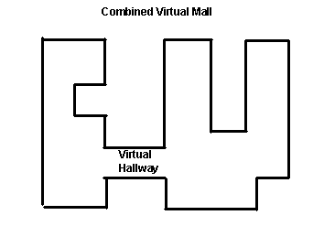
Figure 1. Insert caption to place caption below figure.
Try to place figures next to the text describing them.

Literatur
- Bowman, M., Debray, S. K., and Peterson, L. L. 1993. Reasoning about naming systems. ACM Trans. Program. Lang. Syst. 15, 5 (Nov. 1993), 795-825. DOI= http://doi.acm.org/10.1145/161468.161471.
- Ding, W. and Marchionini, G. 1997 A Study on Video Browsing Strategies. Technical Report. University of Maryland at College Park.

Appendix A – Präsentationsfolien

Appendix B – doKumentation verwendeter Datensätze

Appendix C – Problems encountered Und oFFENE Fragestellungen
Please collect and discuss all problems encountered and open issues identified during the work on your topic.

Appendix D – Dokumentation verwendeter Werkzeuge

(optional) Appendix E
If you need to add your own supplementary material as a separate appendix this would be the right place.

